Ministry of Education
Imam Mohammad Ibn Saud Islamic University
College of Engineering
Civil Engineering Department

CE 492 Graduation Project II

Project Title

By
Name of Student 1 (ID#)
Name of Student 2 (ID#)
Name of Student 4 (ID#)
Name of Student 4 (ID#)

Supervised by
Name of Supervisor

Submitted in partial fulfillment of the requirements of Bachelor’s Degree of Civil Engineering
Graduation Month & Year (such as April or December 2021)

ANTI-PLAGIARISM DECLARATION
(14 Times New Roman, bold, centered)
[Spacing: of 2 x 1.5]
This is to declare that the graduation project, produced under the supervision of Dr. ____________________________________________________, and having the title “_____________________________________________________________________________________________________________” is the sole contribution of the student(s) named below and no part hereof has been reproduced illegally (in particular, cut and paste) which can be considered plagiarism. All referenced parts have been used to support and argue the ideas herein, and have been cited properly. I/we certify that I/we did not commit plagiarize, cheat, and upheld the principles of academic honesty. I/we are responsible and liable for any consequences, if violation of this declaration is proven.

Date: ___________________

Student Name(s): __________________________ Signature: _______________
__________________________ _______________
__________________________ _______________
__________________________ _______________

DEDICATION
(14 Times New Roman, Bold, centered)
[Spacing: of 2 x 1.5]

ACKNOWLEDGMENTS
(14 Times New Roman, Bold, centered)
[Spacing: of 2 x 1.5]

ABSTRACT
(14 Times New Roman, Bold, centered)
[Spacing: of 2 x 1.5]
N.B. In scientific and technological writing, and especially in writing graduation projects reports, engineering students should use a passive voice than an active one because the passive voice is impersonal and thus more formal than active and therefore this latter avoid the use of personal references such as "I" did some experiments, "My" Mathematical model is showing promising results. "We" analyzed the output from different sensors. Etc…….

TABLE OF CONTENTS
(14 Times New Roman, Bold, centered)
[Spacing: of 2 x 1.5]
ANTI-PLAGIARISM DECLARATION II
DEDICATION III
ACKNOWLEDGMENTS IV
ABSTRACT V
TABLE OF CONTENTS VI
LIST OF FIGURES VIII
LIST OF TABLES IX
LIST OF SYMBOLS AND ABBREVIATIONS X
1.1 BACKGROUND (12 Times New Roman) 1
1.2 PROBLEM STATEMENT (12 Times New Roman, Bold) 1
1.3 PROJECT OBJECTIVES (12 Times New Roman, Bold) 1
1.4 OVERVIEW OF THE REPORT (12 Times New Roman, Bold) 2
1.4.1 Chapter One (12 Times New Roman, Bold) 2
1.4.2 Chapter Two (12 Times New Roman, Bold) 2
1.4.3 Chapter Three (12 Times New Roman, Bold) 2
1.4.4 Chapter Four (12 Times New Roman, Bold) 2
1.4.5 Chapter Five (12 Times New Roman, Bold) 2
1.5 SUMMARY (12 Times New Roman, Bold) 2
2.1 SOURCE OF WATER (12 Times New Roman, Bold) 3
3.1 METHODOLOGY (12 Times New Roman, Bold) 4
3.2 GOVERNING EQUATIONS (12 Times New Roman, Bold) 4
4.1 INTRODUCTION (12 Times New Roman, Bold) 5
4.2 THEORETICAL RESULTS (12 Time New Roman, Bold) 5
4.2.1 Analytical and Modeling Results (12 Times New Roman, Bold) 5
4.2.2 Simulation Results (12 Times New Roman, Bold) 5
4.2.3 Discussion and Conclusion (12 Times New Roman, Bold) 6
4.3 EXPERIMENTAL PROCEDURES (12 Times New Roman, Bold) 6
5.1 INTRODUCTION (12 Times New Roman, Bold) 8
5.2 SIGNIFICANCE OF MAIN FINDINGS (12 Times New Roman, Bold) 8
5.3 RECOMMENDATIONS (12 Times New Roman, Bold) 8
Appendix A - ENGINEERING STANDARDS, REALISTIC CONSTRAINTS 11
Appendix B - …………………………………………………….. 12
Appendix C - ……………………………………………………... 13

LIST OF FIGURES
(14 Times New Roman, Bold, Centered)
[Spacing: of 2 x 1.5]
Figure 2.1: Ribbed slab .................................................................................................................5
Figure 2.2: Flat plate .....................................................................................................................7
Figure 3.1: Spread footing ..........................................................................................................11
Figure 3.2: 3D plan of the project ...............................................................................................12
Figure 3.3: layout of each floor ...................................................................................................15
Figure 4.1: Elevation plan for the office building .......................................................................21
Figure 4.2: Reinforcement details of the interior panel (all units in cm). ...................................23
Figure 4.3: Reinforcement details of edge panel (all units in cm). .............. ..............................26
Figure 5.1: Reinforcement details of corner panel (all units in cm). ..........................................33

LIST OF TABLES
(14 Times New Roman, Bold, Centered)
[Spacing: of 2 x 1.5]
Table 2.1: Parameters of design ............................................................................................5
Table 2.2: Minimum slab thickness ......................................................................................7
Table 3.1: Punching shear formulas.....................................................................................12
Table 3.2: Bending moment formulas..................................................................................13
Table 3.3: Column reinforcement calculations formulas.....................................................14
Table 4.1: Footing calculation formulas ............................................................................21
Table 4.2: Input parameters ................................................................................................25
Table 4.3: Check punching shear.........................................................................................26
Table 5.1: Required slab reinforcement calculation for interior panel in short direction. ..32

LIST OF SYMBOLS AND ABBREVIATIONS
(14 Times New Roman, Bold, Centered)
[Spacing: of 2 x 1.5]

CHAPTER 1: INTRODUCTION, PROBLEM STATEMENT
1 inch
(14 Times New Roman, Bold, centered)
[Spacing: of 3 x 1.5]

1.1 BACKGROUND (12 Times New Roman)
For the successful completion of a project, planning and scheduling are the two most important factors. The construction industry's demand requires precise planning, scheduling, and management, which can allow the overall optimization of the cost, time, and resources. Due to the increase in workload and shrinkage resources, the public work department found new technology, which efficiently manages the project. Project management software is used to collect and organize work, which helps industries to overgrow. There is so much computer software available in the market, now a day, such as Microsoft Project and Primavera P6 for project management. With the help of this software, proper planning and controlling of the project can be done. Primavera can easily compare the planned progress of construction work and the actual progress of construction projects. Project management software primavera P6 includes collecting, recording, monitoring, controlling, and reporting information concerning project performance. In this study, the project scheduling, managing, and monitoring are planned, and causes of delays are documented.
1 inch
1 inch
[Spacing: of 2 x 1.5]

1.2 PROBLEM STATEMENT (12 Times New Roman, Bold)
The Faculty of Engineering is one of the applied scientific colleges within the new faculties system at the Imam Muhammad bin Saud Islamic University. It was established at the beginning of the academic year 1430 / 1431 (2009/2010), as well as through halls equipped with the best scientific and teaching methods and the best available teaching methods, where the college is working on the preparation of engineers in all fields of electrical engineering, mechanical engineering, chemical engineering, and civil engineering. 2
[Spacing: of 2 x 1.5]

1.3 PROJECT OBJECTIVES (12 Times New Roman, Bold)
The following are the objectives for this graduation project:
● Understand project planning and scheduling, emphasizing responsibilities of the owner, designers/consultants, and contractors.
● Conduct interviews with key stakeholders and managers to learn about planning and scheduling implementation on the construction project.
1 inch
● Finalize a questionnaire to collect information from owners, consultants, and contractors about construction schedules, techniques, and benefits.
[Spacing: of 2 x 1.5]

1.4 OVERVIEW OF THE REPORT (12 Times New Roman, Bold)
Here you present a brief overview of a report designed to give the reader a quick preview of the report's contents.

1.4.1 Chapter One (12 Times New Roman, Bold)
This chapter introduces the project, discussed the problem statement, and finalized the project's completed objectives.
[Spacing: of 2 x 1.5]

1.4.2 Chapter Two (12 Times New Roman, Bold)
This chapter documents the literature review related to construction planning and scheduling. It explains construction planning, defines planning tools, and provides information about scheduling software.
[Spacing: of 2 x 1.5]

1.4.3 Chapter Three (12 Times New Roman, Bold)
In this chapter, we explained the project's methodology and documented how the questionnaire was finalized for the interviews and for collecting the data. The selected case study project - College of the engineering building, is explained in this chapter. 3
[Spacing: of 2 x 1.5]

1.4.4 Chapter Four (12 Times New Roman, Bold)
This chapter analyses the interview and the questionnaire survey. It gives results of the interviews and the questionnaire survey. It provided scheduling for the case study project - the College of Engineering.
[Spacing: of 2 x 1.5]

1.4.5 Chapter Five (12 Times New Roman, Bold)
This chapter documents conclusion for the graduation project.
[Spacing: of 2 x 1.5]

1.5 SUMMARY (12 Times New Roman, Bold)
In this chapter, we recognized the importance of planning and the most important programs used, in addition to what is discussed throughout this project
CHAPTER 2: LITERATURE REVIEW
(14 Times New Roman, Bold, centered)
[Spacing: of 3 x 1.5]

2.1 SOURCE OF WATER (12 Times New Roman, Bold)
This project has studied four water supply sources: Dam, Groundwater, and two desalination plants have a different design, analysis, and cost. Therefore, it was required to design transmission lines from the source of water to Afif city, considering the topography of the region and distance
[Spacing: of 2 x 1.5]
$h_{f}=k⋅Q^{n}$ (2.1)
$Q_{1}=Q_{0}+ΔQ$ (2.2)

CHAPTER 3: DESIGN / METHODOLOGY / MATHEMATICAL MODELING / SIMULATIONS (14 Times New Roman, Bold, Centered)

[Spacing: of 3 x 1.5]

3.1 METHODOLOGY (12 Times New Roman, Bold)
Many programs and equations are involved in this project to help ease the analysis and design of transmission lines, water networks, and flood protection with satisfactory outcomes.
[Spacing: of 2 x 1.5]

3.2 GOVERNING EQUATIONS (12 Times New Roman, Bold)
[Spacing: of 2 x 1.5]
H_{p} =H_{S} + H_{L} (3.1)

CHAPTER 4: RESULTS AND DISCUSSION
(14 Times New Roman, Bold, Centered)

[Spacing: of 3 x 1.5]

4.1 INTRODUCTION (12 Times New Roman, Bold)
Robot Structural Analysis Figure 4.1 was used for the structural design of the building elements for this study. Autodesk produces it, and it is an integrated graphics program for modeling, analyzing, and designing various types of structures. It lets you create structures, carry out calculations, and verify results. It also enables you to create documentation for the developed and calculated design. Furthermore, it has become one of the best tools for designing, simulating, and analyzing structures worldwide. Being the first option in countries like the USA, United Kingdom, France, Germany, The Netherlands, Australia, United Arab Emirates, Peru, and many more. We have taken a course to learn how to use this tool to design and analyze the structure, and it took two months to learn it.
[Spacing: of 2 x 1.5]

4.2 THEORETICAL RESULTS (12 Time New Roman, Bold)
It was introduced to know how to design some structural elements (column and slab) by using robots.
1- Open the software
2- Select the type of element you want to design (Column, slab, beam, foundation) or superior building design to develop the whole building, as shown in figure 4.2.
[Spacing: of 2 x 1.5]

4.2.1 Analytical and Modeling Results (12 Times New Roman, Bold)
In this section, the area required and the number of reinforcements for each structure element is discussed.
[Spacing: of 2 x 1.5]

4.2.2 Simulation Results (12 Times New Roman, Bold)
Figure 4.1 shows the variation of the amount of steel in the panels where the dark means more steel required.

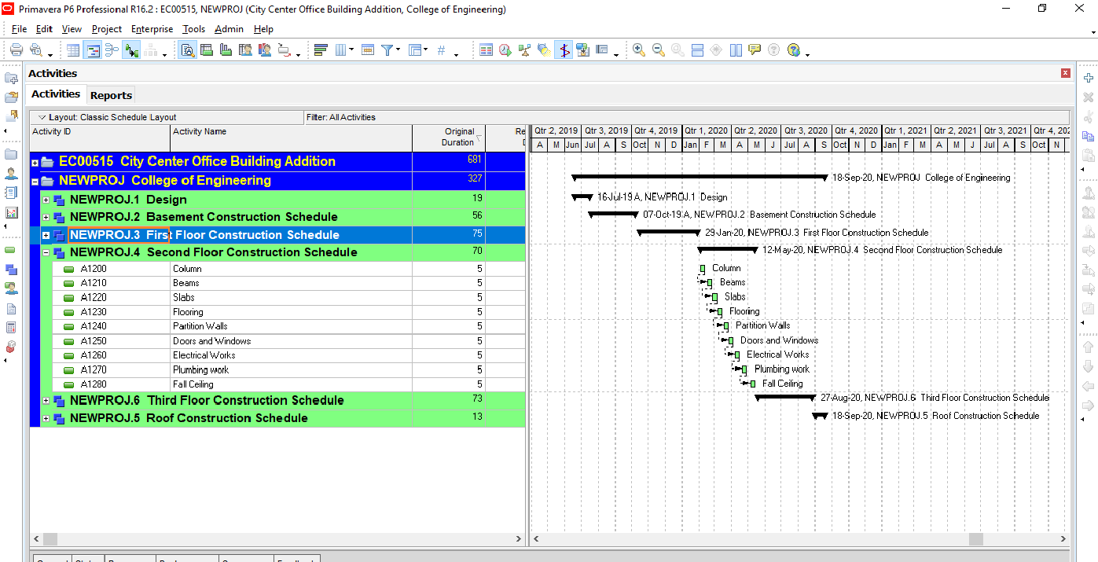
Figure 4.1. ******** (12 Times New Roman) [Spacing of 1 from figure]
[Spacing: of 2 x 1.5]

4.2.3 Discussion and Conclusion (12 Times New Roman, Bold)
In the building, there are 25 interiors, 4 corners, and 20 edge columns.
Table 4.2 below shows required reinforcement on central, construction, and stirrups for interior columns, and figure 4.26 (a) shows cross-section where (b) shows the 3D modeling.
[Spacing: of 2 x 1.5]
Table 4.2: Required reinforcement for interior columns (12 Times New Roman) [Spacing of 1 from the table]
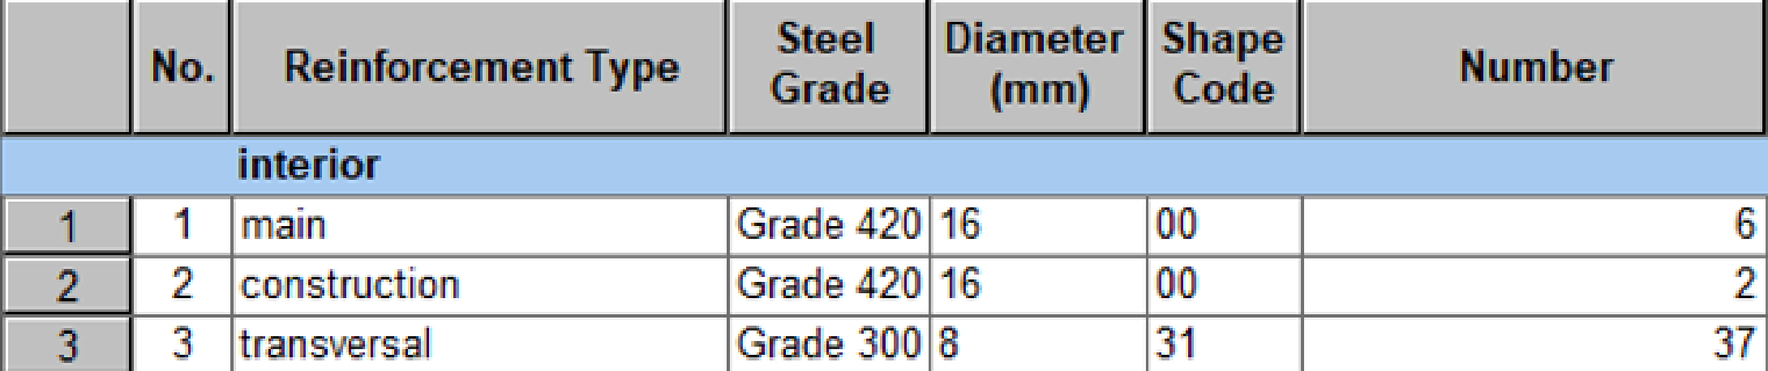
[Spacing: of 2 x 1.5]

4.3 EXPERIMENTAL PROCEDURES (12 Times New Roman, Bold)
Write the experimental procedure is to give step-by-step details of your experiments. A typical method is so detailed that it lets someone else can repeat your experiment accurately.
[Spacing: of 2 x 1.5]
4.3.1 Measurements Description (12 Times New Roman, Bold)
………………………………………………………………………………………………………………………………………………………………………………………………
[Spacing: of 2 x 1.5]
4.3.2 Results and Discussions (12 Times New Roman, Bold)
……………………………………………………………………………………………………………………………………………………………………………………………

CHAPTER 5: GENERAL CONCLUSIONS AND SUGGESTIONS FOR FURTHER WORK (14 Times New Roman, Bold, Centered)
[Spacing: of 3 x 1.5]

5.1 INTRODUCTION (12 Times New Roman, Bold)
………………………………………………………………………………………………………………………………………………………………………………………………
[Spacing: of 2 x 1.5]

5.2 SIGNIFICANCE OF MAIN FINDINGS (12 Times New Roman, Bold)
………………………………………………………………………………………………………………………………………………………………………………………………
[Spacing: of 2 x 1.5]

5.3 RECOMMENDATIONS (12 Times New Roman, Bold)
………………………………………………………………………………………………………………………………………………………………………………………………

REFERENCES (14 Times New Roman, Bold, Centered)
[Spacing: of 2 x 1.5]
References should be added at the end of the report, and its corresponding citation will be added in the order of their appearance in the text by a number enclosed in brackets as [1], [2],[3], etc.……... Students should ensure that every reference in the text appears in the list of references and vice versa.
SAMPLES

Reference to a journal publication:
[1] Alnasseri, H., and Aulin, R. (2015). Assessing understanding of planning and scheduling theory and practice on construction projects. Engineering Management Journal. 27 (2) 58-72.
[2] Andersen, E.S. (1996). Warning: Activity planning is hazardous to your project’s health! International Journal of Project Management. 14 (2) 89-94.
Reference to a book:
[3] Strunk, W., and. White, E.B (2000). The Elements of Style, fourth ed., Longman, New York,
Reference to a chapter in an edited book:
[4] Mettam, G.R. and. Adams, L.B. (2009). How to prepare an electronic version of your article, in: B.S. Jones, R.Z. Smith (Eds.), Introduction to the Electronic Age, E-Publishing Inc., New York, 281-304.
Reference to a website:
[5] Cancer Research UK, Cancer statistics reports for the UK (2003).
http://www.cancerresearchuk.org/aboutcancer/statistics/cancerstatsreport/ (accessed 20 March 2020).

APPENDICES
[Spacing: of 2 x 1.5]
Note: Include in the appendices information that could not be included in the report's formal body because it would disrupt the continuity of the discussion. Background materials, product catalogs, experimental data tables, and extra documentation should be placed in the appendix.
Authors including an appendix section should do so after the References section. Multiple appendices should have headings in style. They will automatically be ordered A, B, C, etc. ‘Els-appendix head’ style is available in this template for the appendices.

ENGINEERING STANDARDS, REALISTIC CONSTRAINTS

……………………………………………………..

……………………………………………………...

General guidelines for Formatting

Format | Items
see GP‐ guidelines | Cover Page
-Chapter title font size 14 bold, all capital  -Section font size 12 bold, all capital  -Sub‐section font size 12 bold,  - Text font size 12 Times New Roman | Typeface:
-Left, Right, Upper, and Lower  Margins: 1 inch each | Page Margins:
-Line spacing of 1.5 is required in the main body of the manuscript  -single Spacing for footnotes, indented quotations, tables | Line Spacing:
Each page of the manuscript, including all blank pages and pages with photographs, tables, figures, maps, and computer program printouts, should be assigned a number as presented in GP-guidelines | Pagination:
Table Caption, Figure Caption, and Equation Numbers as presented in GP-guidelines | Caption:
as in GP-guidelines | References

