Ministry of Education

Imam Mohammad Ibn Saud Islamic University
College of Engineering
Electrical Engineering Department

EE 494 Graduation Project II

Project Title

By
Name of Student 1 (ID#)
Name of Student 2 (ID#)
Name of Student 4 (ID#)
Name of Student 4 (ID#)

Supervised by
Name of Supervisor

Submitted in partial fulfilment for the requirements of Bachelor’s Degree of
Electrical Engineering
Graduation Month & Year (such as April or December 2021)
ANTI-PLAGIARISM DECLARATION
(14 Times New Roman, bold, centered)
[Spacing: of 2 x 1.5]
This is to declare that the graduation project, produced under the supervision of Dr. ____________________________________________________, and having the title “_____________________________________________________________________________________________________________” is the sole contribution of the student(s) named below and no part hereof has been reproduced illegally (in particular, cut and paste) which can be considered plagiarism. All referenced parts have been used to support and argue the ideas herein, and have been cited properly. I/we certify that I/we did not commit plagiarize, cheat, and upheld the principles of academic honesty. I/we are responsible and liable for any consequences, if violation of this declaration is proven.

Date: ___________________

Student Name(s): __________________________ Signature: _______________
__________________________ _______________
__________________________ _______________
__________________________ _______________

DEDICATION (14 Times New Roman, Bold ,centered)
[Spacing: of 2 x 1.5]

ACKNOWLEDGMENTS (14 Times New Roman, Bold, centered)
[Spacing: of 2 x 1.5]

ABSTRACT (14 Times New Roman, Bold, centered)
[Spacing: of 2 x 1.5]
N.B. In a scientific and technological writing, and especially in writing graduation projects reports, it is advisable for engineering students to use passive voice than active one, because the passive voice is impersonal and thus more formal than active and thus this latter avoid the use of personal references such as "I" did some experiments, "My" Mathematical model is showing good results. "We" analyzed the output from different sensors. Etc…….

PROJECT DOMAIN
Related to Global and Local Sustainable Development Goals (Select all possible options)





Related to National Research Priorities (Select all possible options)
Health & Wellness
Sustainable Environment & Affordable Supply of Essential Needs
Energy & Industrial Leadership
Economies of the Future

Conform to NASA Technology Readiness Level (TRL) (Select all possible options)
Link to | TRL | Definition | Description
 | 1 | Basic principles observed and reported | Scientific research begins, generating foundational knowledge for future applications
 | 2 | Technology concept and/or application formulated | Initial ideas are developed; however, they remain speculative without experimental proof
 | 3 | Analytical and experimental critical function and/or characteristic proof of concept | Active research leads to proof-of-concept models through laboratory studies and simulations
 | 4 | Component and/or breadboard validation in a relevant environment | Components are integrated and tested together in a controlled environment
 | 5 | System/component validation in a relevant environment | A breadboard system is tested in conditions that simulate real operational environments
 | 6 | System/sub-system model or prototype demonstration in an operational environment | A fully functional prototype is demonstrated in conditions that reflect actual operational scenarios
 | 7 | System prototype demonstration in an operational environment | A high-fidelity prototype is tested in the actual operational environment, demonstrating its capabilities
 | 8 | Actual system completed and "flight qualified" through test and demonstration | The final product is tested and validated for its intended operational use, ensuring all systems are integrated
 | 9 | Actual system flight proven through successful mission operations | The technology has been successfully deployed in missions, demonstrating its reliability and effectiveness
Source: https://www.un.org/sustainabledevelopment/
https://www.nasa.gov/

TABLE OF CONTENTS (14 Times New Roman, Bold , centered)
[Spacing: of 2 x 1.5]
ANTI-PLAGIARISM DECLARATION (14 Times New Roman) II
DEDICATION (14 Times New Roman) III
ACKNOWLEDGMENTS (14 Times New Roman) IV
ABSTRACT (14 Times New Roman) V
TABLE OF CONTENTS (14 Times New Roman) VI
LIST OF FIGURES (14 Times New Roman) VIII
LIST OF TABLES (14 Times New Roman) IX
LIST OF SYMBOLES AND ABREVIATIONS (14 Times New Roman) X
CHAPTER 1: INTRODUCTION, PROBLEM STATEMENT (14 Times New Roman) 1
1.1 BACKGROUND (12 Times New Roman) 1
1.2 PROBLEM STATEMENT (12 Times New Roman) 1
1.3 PROJECT OBJECTIVES (12 Times New Roman) 1
1.4 OVERVIEW OF THE REPORT (12 Times New Roman) 2
1.4.1 Chapter One (12 Times New Roman) 2
1.4.2 Chapter Two (12 Times New Roman) 2
1.4.3 Chapter Three (12 Times New Roman) 2
1.4.4 Chapter Four (12 Times New Roman) 2
1.4.5 Chapter Five (12 Times New Roman) 2
1.5 SUMMARY (12 Times New Roman) 2
CHAPTER 2: LITERATURE REVIEW (14 Times New Roman) 3
2.1 SOURCE OF WATER (12 Times New Roman) 3
CHAPTER 3: DESIGN/METHODOLOGY/MATHEMATICAL MODELING/SIMULATIONS (14 Times New Roman) 4
3.1 METHODOLOGY (12 Times New Roman) 4
3.2 GOVERNING EQUATIONS (12 Times New Roman) 4
CHAPTER 4: RESULTS AND DISCUSSION (14 Times New Roman) 5
4.1 INTRODUCTION (12 Times New Roman) 5
4.2 THEORETICAL RESULTS (12 Time New Roman) 5
4.2.1 Analytical and modeling results (12 Times New Roman) 5
4.2.2 Simulation results (12 Times New Roman) 5
4.2.3 Discussion and conclusion (12 Times New Roman) 6
4.3 EXPERIMENTAL RESULTS (12 Times New Roman) 6
CHAPTER 5: GENERAL CONCLUSIONS AND SUGGESTIONS FOR FURTHER WORK (14 Times New Roman) 8
5.1 INTRODUCTION (12 Times New Roman) 8
5.2 SIGNIFICANCE OF MAIN FINDINGS (12 Times New Roman) 8
5.3 RECOMMENDATIONS (12 Times New Roman) 8
REFERENCES (14 Times New Roman) 9
APPENDICES (14 Times New Roman) 10
Appendix A -ENGINEERING STANDARDS, REALISTIC CONSTRAINTS (14 Times New Roman) ……………………………………………………..
Appendix B -(14 Times New Roman)……………………………………………………..
Appendix C - (14 Times New Roman)…………………………………………………...

LIST OF FIGURES (14 Times New Roman, Bold, Centered)
[Spacing: of 2 x 1.5]
Figure 2.1: Ribbed slab .................................................................................................................5
Figure 2.2: Flat plate .....................................................................................................................7
Figure 3.1: Spread footing ..........................................................................................................11
Figure 3.2: 3D plan of the project ...............................................................................................12
Figure 3.3: layout of each floor ...................................................................................................15
Figure 4.1: Elevation plan for the office building .......................................................................21
Figure 4.2: Reinforcement details of the interior panel (all units in cm). ...................................23
Figure 4.3: Reinforcement details of edge panel (all units in cm). .............. ..............................26
Figure 5.1: Reinforcement details of corner panel (all units in cm). ..........................................33

LIST OF TABLES (14 Times New Roman, Bold, Centered)
[Spacing: of 2 x 1.5]
Table 2.1: Parameters of design ............................................................................................5
Table 2.2: Minimum slab thickness ......................................................................................7
Table 3.1: Punching shear formulas.....................................................................................12
Table 3.2: Bending moment formulas..................................................................................13
Table 3.3: Column reinforcement calculations formulas.....................................................14
Table 4.1: Footing calculation formulas ............................................................................21
Table 4.2: Input parameters ................................................................................................25
Table 4.3: Check punching shear.........................................................................................26
Table 5.1: Required slab reinforcement calculation for interior panel in short direction. ..32

LIST OF SYMBOLES AND ABREVIATIONS
(14 Times New Roman, Bold, Centered)
[Spacing: of 2 x 1.5]

CHAPTER 1: INTRODUCTION AND PROBLEM STATEMENT ¹
1 inch
[Spacing: of 3 x 1.5]

1.1 BACKGROUND (12 Times New Roman)
For the successful completion of a project, planning and scheduling are two most important factors. The demand of construction industry requires a precise planning, scheduling and management, which can allow the overall optimization of the cost, time and resources. Due to the increase in workload and shrinkage resources, public work department found new technology, which helps to manage the project efficiently. Project management software is used as a tool for managing and organizing work, which helps industries to overgrow. There is so computer software is available in market, now a day, which is such as Microsoft Project and Primavera P6 for doing project management. With help of this software, proper planning and controlling of project can be done. Primavera can easily compare between the planned progress of construction work and actual progress of construction project. Project management software primavera P6, include collecting, recording, monitoring, controlling and reporting information concerning project performance. In this study, the project scheduling, controlling and monitoring is planned and causes of delays are documented.
1 inch
1 inch
[Spacing: of 2 x 1.5]

1.2 PROBLEM STATEMENT (12 Times New Roman, Bold)
The Faculty of Engineering is one of the applied scientific colleges within the system of new faculties at the Imam Muhammad bin Saud Islamic University. It was established at the beginning of the academic year 1430 / 1431 (2009/2010), as well as through halls equipped with the best scientific and teaching methods and the best available teaching methods, where the college is working on the preparation of engineers in all fields of electrical engineering, mechanical engineering, chemical engineering, and civil engineering. 2
[Spacing: of 2 x 1.5]

1.3 PROJECT OBJECTIVES (12 Times New Roman, Bold)
The following are the objectives for this graduation project:
● Understand project planning and scheduling with emphasis on responsibilities of owner, designers/consultants, and contractors.
● Conduct interviews with key stakeholders and managers to learn about planning and scheduling implementation on construction project.
1 inch
● Finalize a questionnaire to collect information from owners, consultants, and contractors about construction scheduling, its techniques, and benefits.
[Spacing: of 2 x 1.5]

1.4 OVERVIEW OF THE REPORT (12 Times New Roman, Bold)
Here you present a brief overview of a report that is designed to give the reader a quick preview of the report's contents.

1.4.1 Chapter One (12 Times New Roman, Bold)
In this chapter, we introduce the project, discussed the problem statement, and finalized objectives of the project.
[Spacing: of 2 x 1.5]

1.4.2 Chapter Two (12 Times New Roman, Bold)
This chapter documents the literature review related to construction planning and scheduling. It explains about construction planning, define planning tools, and provide information about scheduling software.
[Spacing: of 2 x 1.5]

1.4.3 Chapter Three (12 Times New Roman, Bold)
In this chapter, we explained the methodology of the project and documented how the questionnaire was finalized for the interviews and for collecting the data. The selected case study project - College of engineering building, is explained in this chapter. 3
[Spacing: of 2 x 1.5]

1.4.4 Chapter Four (12 Times New Roman, Bold)
This chapter analyses the interview and the questionnaire survey. It gives results of the interviews and the questionnaire survey. It provided scheduling for the case study project - the College of Engineering.
[Spacing: of 2 x 1.5]

1.4.5 Chapter Five (12 Times New Roman, Bold)
This chapter documents conclusions for the graduation project.
[Spacing: of 2 x 1.5]

1.5 SUMMARY (12 Times New Roman, Bold)
In this chapter, we recognized the importance of planning and the most important programs used, in addition to what it is discussed throughout this project

CHAPTER 2: LITERATURE REVIEW
[Spacing: of 3 x 1.5]

2.1 SOURCE OF WATER (12 Times New Roman, Bold)
In this project, we have studied four sources of water supply: Dam, Groundwater, and two desalination plants have different design, analysis and cost. Therefore, it was required to design transmission lines from the source of water to Afif city, considering the topography of the region and distance
[Spacing: of 2 x 1.5]
$h_{f}=k⋅Q^{n}$ (2.1)
$Q_{1}=Q_{0}+ΔQ$ (2.2)

CHAPTER 3: DESIGN / METHODOLOGY / MATHEMATICAL MODELING / SIMULATIONS
[Spacing: of 3 x 1.5]

3.1 METHODOLOGY (12 Times New Roman, Bold)
Many programs and equations are involved in this project to help ease the analysis and design of transmission lines, water network and flood protection with satisfactory outcomes.
[Spacing: of 2 x 1.5]

3.2 GOVERNING EQUATIONS (12 Times New Roman, Bold)
[Spacing: of 2 x 1.5]
H_{p} =H_{S} + H_{L} (3.1)

CHAPTER 4: RESULTS AND DISCUSSION
[Spacing: of 3 x 1.5]

4.1 INTRODUCTION (12 Times New Roman, Bold)
Robot Structural Analysis Figure 4.1 was used to structural design of the building elements for this study. Autodesk produces it and it is an integrated graphics program for modeling, analyzing and designing various types of structures. It lets you create structures, carry out calculations, and verify results. It also lets you create documentation for the designed and calculated structure. Furthermore, it has become one of the best tools for designing, simulation and analysis of structures worldwide. Being the first option in countries like the USA, United Kingdom, France, Germany, The Netherlands, Australia, United Arab Emirates, Peru and many more. We have taken a course to learn how to use this tool to design and analyze the structure and it took two months to learn it.
[Spacing: of 2 x 1.5]

4.2 THEORETICAL RESULTS (12 Time New Roman, Bold)
It was introduced some steps to know how to design some structural elements (column and slab) by using robots.
1- Open the software
2- Select the type of element that you want to design (Column, slab, beam, foundation) or select building design to design the whole building as shown in figure 4.2.
[Spacing: of 2 x 1.5]

4.2.1 Analytical and modeling results (12 Times New Roman, Bold)
In this section, the result for the area required and number of reinforcements for each element of structure is discussed.
[Spacing: of 2 x 1.5]

4.2.2 Simulation results (12 Times New Roman, Bold)
Figure 4.1 shows the variation of the amount of steel in the panels where the dark means more area of steel required.

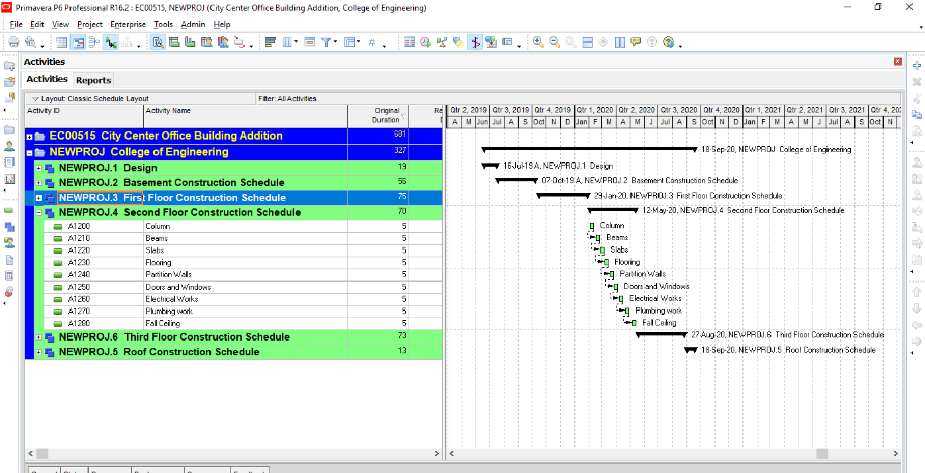
Figure 4.1. ******** (12 Times New Roman) [Spacing of 1 from figure]
[Spacing: of 2 x 1.5]

4.2.3 Discussion and conclusion (12 Times New Roman, Bold)
In the building, there is 25 interiors, 4 corners, and 20 edge columns.
Table 4.2 below shows required reinforcement on central, construction, and stirrups for interior columns and figure 4.26 (a) shows cross-section where (b) shows the 3D modeling.
[Spacing: of 2 x 1.5]
Table 4.2: Required reinforcement for interior columns (12 Times New Roman) [Spacing of 1 from table]
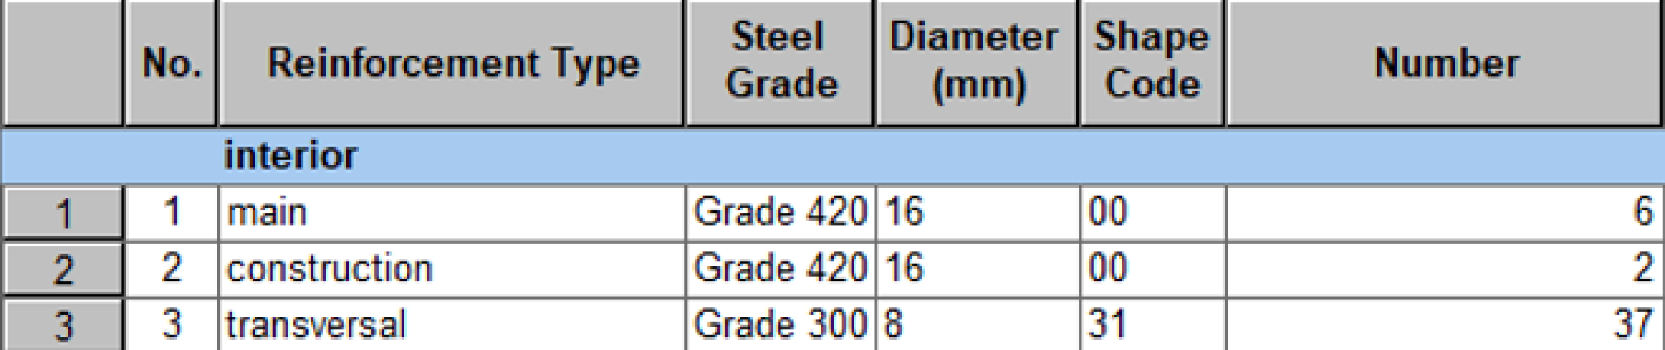
[Spacing: of 2 x 1.5]

4.3 EXPERIMENTAL PROCEDURES (12 Times New Roman, Bold)
Write the experimental procedure is to give a step-by-step details of your experiments. A typicall procedure is so detailed that it lets someone else can repete your experiment accurately.
[Spacing: of 2 x 1.5]
4.3.1 Measurements description (12 Times New Roman, Bold)
………………………………………………………………………………………………………………………………………………………………………………………………
[Spacing: of 2 x 1.5]
4.3.2 Results and discussions (12 Times New Roman, Bold)
……………………………………………………………………………………………………………………………………………………………………………………………

CHAPTER 5: GENERAL CONCLUSIONS AND SUGGESTIONS FOR FURTHER WORK
[Spacing: of 2 x 1.5]

5.1 INTRODUCTION (12 Times New Roman, Bold)
………………………………………………………………………………………………………………………………………………………………………………………………
[Spacing: of 2 x 1.5]

5.2 SIGNIFICANCE OF MAIN FINDINGS (12 Times New Roman, Bold)
………………………………………………………………………………………………………………………………………………………………………………………………
[Spacing: of 2 x 1.5]

5.3 RECOMMENDATIONS (12 Times New Roman, Bold)
………………………………………………………………………………………………………………………………………………………………………………………………

REFERENCES (14 Times New Roman, Bold, Centered)
[Spacing: of 2 x 1.5]
References should be added at the end of the report, and its corresponding citation will be added in the order of their appearance in the text by a number enclosed in brackets as [1], [2],[3] etc……... Students should ensure that every reference in the text appears in the list of references and vice versa.
SAMPLES

Reference to a journal publication:
[1] Alnasseri, H., and Aulin, R. (2015). Assessing understanding of planning and scheduling theory and practice on construction projects. Engineering Management Journal. 27 (2) 58-72.
[2] Andersen, E.S. (1996). Warning: Activity planning is hazardous to your project’s health! International Journal of Project Management. 14 (2) 89-94.
Reference to a book:
[3] Strunk, W., and. White, E.B (2000). The Elements of Style, fourth ed., Longman, New York,
Reference to a chapter in an edited book:
[4] Mettam, G.R. and. Adams, L.B. (2009). How to prepare an electronic version of your article, in: B.S. Jones, R.Z. Smith (Eds.), Introduction to the Electronic Age, E-Publishing Inc., New York, 281-304.
Reference to a website:
[5] Cancer Research UK, Cancer statistics reports for the UK (2003).
http://www.cancerresearchuk.org/aboutcancer/statistics/cancerstatsreport/ (accessed 20 March 2020).

APPENDICES
[Spacing: of 2 x 1.5]
Note: Include in the appendices information that could not be included in the formal body of the report because it would disrupt the continuity of the discussion. Background materials, product catalogs, experimental data tables, and extra documentation should be placed in the appendix.
Authors including an appendix section should do so after the References section. Multiple appendices should have headings in the style. They will automatically be ordered A, B, C etc. ‘Els-appendix head’ style is available in this template for the appendices.

ENGINEERING STANDARDS, AND REALISTIC CONSTRAINTS

……………………………………………………..

……………………………………………………...

General guidelines for Formatting

Format | Items
see GP‐ guidelines | Cover Page
-Chapter title font size 14 bold, all capital  -Section font size 12 bold, all capital  -Sub‐section font size 12 bold,  - Text font size 12 Times New Roman | Typeface:
-Left, Right, Upper, and Lower  Margins: 1 inch each | Page Margins:
-Line spacing of 1.5 is required in the main body of the manuscript  -single spacing for footnotes, indented quotations, tables | Line Spacing:
Each page of the manuscript, including all blank pages, and pages with photographs, tables, figures, maps, and computer program printouts should be assigned a number as presented in GP-guidelines | Pagination:
Table Caption, Figure Caption and Equation Numbers as presented in GP-guidelines | Caption:
as in GP-guidelines | References

